**TITLE OF PROJECT**

RAILWAY RESERVATION SYSTEM

END TERM REPORT

***by***

*Nikita Kaushik*

**NAME OF THE CANDIDATE(S)**

Section: K19BY

Roll Number(s): 19 ,20 ,21



**Department of Intelligent Systems**

**School of Computer Science Engineering**

**Lovely Professional University, Jalandhar**

Month-Year : April 2020

**Student Declaration**

This is to declare that this report has been written by Sudharshan Reddy , Sourabh Kumar , Khushboo Shakya . No part of the report is copied from other sources. All information included from other sources have been duly acknowledged. We aver that if any part of the report is found to be copied, I/we are shall take full responsibility for it.

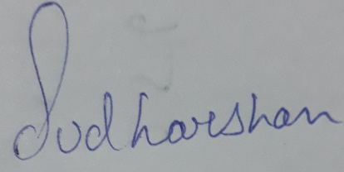

Sudharshan Reddy

19



Sourabh Kumar

20

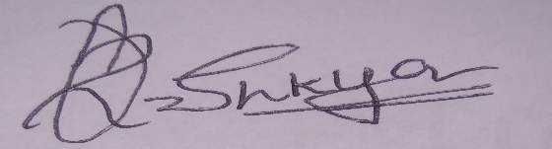

Khushboo Shakya

21

Place: Jalandhar, Punjab

Date: 8 April 2020

**TABLE OF CONTENTS**

**1. Background and objectives of project assigned 1**

**1.1 Background 1**

**1.1.1 Motivation 1**

**1.1.2 Outcomes 1**

**1.2 Concrete goals** 2

**1.2.1 Objectives 2**

**2.Description 2**

**2.1 Description of Project 3-5**

**2.2 Work Done by each student 6**

**2.3 Description of scheduled work with screenshots 7-11**

**2.4 SWOT analysis 12**

BONAFIDE CERTIFICATE

Certified that this project report “ONLINE RAILWAY TICKET BOOKING SYSTEM” is the bonafide work of “KHUSHBOO SHAKYA, SOURABH KUMAR, SUDHARSHAN REDDY ” who carried out the project work under my supervision.

<<Signature of the Supervisor >>

Name of supervisor: - Nikita Kaushik

Academic Designation: -Professor

ID of Supervisor: -25821

Department of Supervisor: - Computer Science and Engineering

**Background and Objectives of project assigned** :

**BACKGROUND :**

This is online railway ticket booking website because the existing system is completely paper based. So  this system needs lots of man power and as this system needs lots of manpower and as papers will be moving from one place to another manually, lots of time is consumed. So time constraints maintenance is very difficult.

So , in order to manage the time we selected this path. So , from now no need to waste your valuable time in booking your ticket in railways .Just you need to open our website and book the online ticket .

**MOTIVATION** :

The motivation of making this website is to reduce the wastage of valuable time of the passenger in order for searching for the railway ticket . Because the passenger may be business person , senior citizen and politician etc . He/She don’t have a time to book the ticket on railway station , and there is lot of headache in standing in a line in railway station for taking the ticket . So , our website will easily help them for avoiding such kind dilemma of passenger .

**OUTCOMES**:

The major outcome in the designing of this website is to reduce the wastage of time of the passenger because if the person wants to book the ticket in railway station then the system will completely paper based. So, this system will need lots of man power and as this system needs lots of manpower. This may waste lot of time for that person. For avoiding such kind of problem our website is there to help them.

**CONCRETE GOALS: -**

Our goal is to be the top in real estate website. To bring we need to bring more and more passenger. And our passenger should be satisfied with our properties offered in our website like as price of the ticket , location of the train etc . We are also providing booking system keeps track of each reservation and the details tied to it. This means that passenger can use reports to find what tours are making you the most money and this will help in building the trust on this website of the passenger .

**OBJECTIVES: -**

In this competitive era ,their are many objectives of our website such as provide a secured online booking facility to be used by the railway authorized employee to manage the proposed system online facility . Provide an alternative system that will be used and interfaced by the authorized railway employee to manage the system facility and utility. And our main objective is also provide a messaging services in delivering passenger railway information: email and SMS service.

**DESCRIPTION: -**

**DESCRIPTION OF PROJECT (module wise):-**

In a home page of website ,their are different different kind of module like as home, meals , holiday packages , service at station , contact us. These menus have further sub menus

**SYSTEM DESIGN**

MAIN WINDOW

SERVICE AT STATION

MEALS

HOLIDAY PACKAGES

HOME

CONTACT US

The description of the following modules are :

International Cuisines

MEALS

Logout

Cancel Tickets

Booking History

Transactions

Login/sign up

HOME

North Indian Foods

South Indian Foods

Battery Operated cars

E-Wheelchairs

Wi-Fi Railway Stations

Retiring Rooms

SERVICE AT STATION

NATIONAL PACKAGES

INTERNATIONAL PACKAGES

HOLIDAY PACKAGES

Feedback

E-mail us

CONTACT US

Contact No. and Address.

Contact No. and Address.

Module Description:

1. – this module contains link so that user can login can view all the transaction

HOME

and booked tickets.

2. - contains the types of foods and price of meals available during journey

MEALS

3.. - contains type of holiday packages like national and international packages respective prices and visiting places.

SERVICE AT STATION

HOLIDAY PACKAGES

4. - -contains the description of services

CONTACT US

5. - contains the contact details of the railway reservation service for any complaint.

**WORK DONE BY EACH STUDENT OF THE WORK:**

We used basically html, css and javascript for the designing of the website we create different html documents to let the user to navigate on different pages according to the option given on website. We use css for the styling purpose. We also use javascript to make the website more attractive.We have made all these files on notepad and link them with each other and run them on the chrome browser as the files are linked with each other on opening any html file the whole website get opened.

Now the explanation of work done by each student:

Sudharshan Reddy :-He collect the information regarding file and collect various images for website.

Sourabh Kumar :- Code and Design Rectification.

Khushboo Shakya :- Designing The layout of the page and flow of website and report work.

**DESCRIPTION OF SCHEDULED WORK WITH SCREENSHOTS OF DESIGNED WEB PAGES:**

1.HOME -This module contains link so that user can login can view all the transaction and booked tickets.

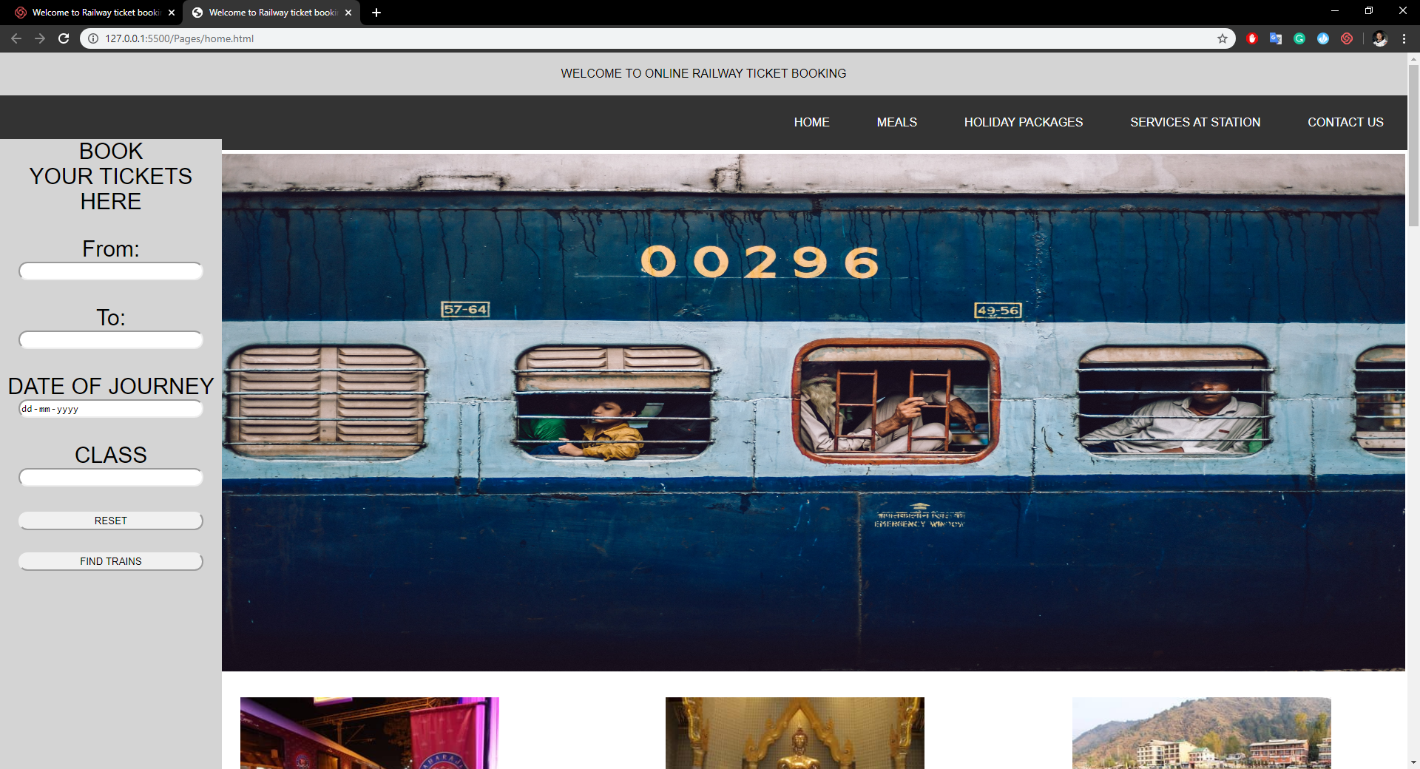

2.Login/Signup: User create Account or login here after entering the Details.

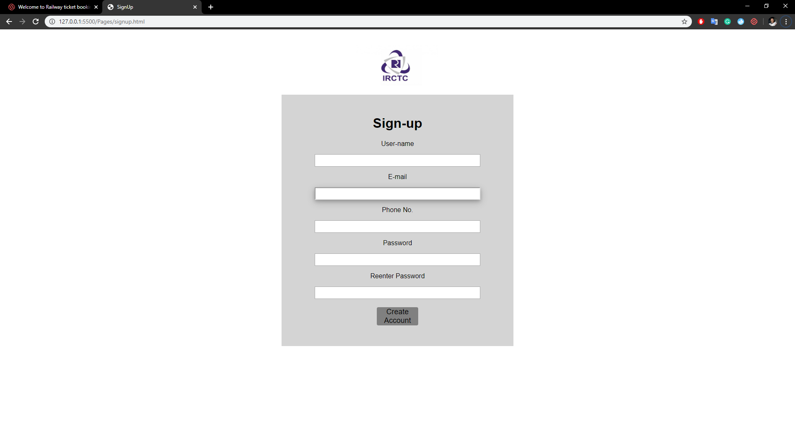

1. MEALS :-contains the types of foods and price of meals available during journey. 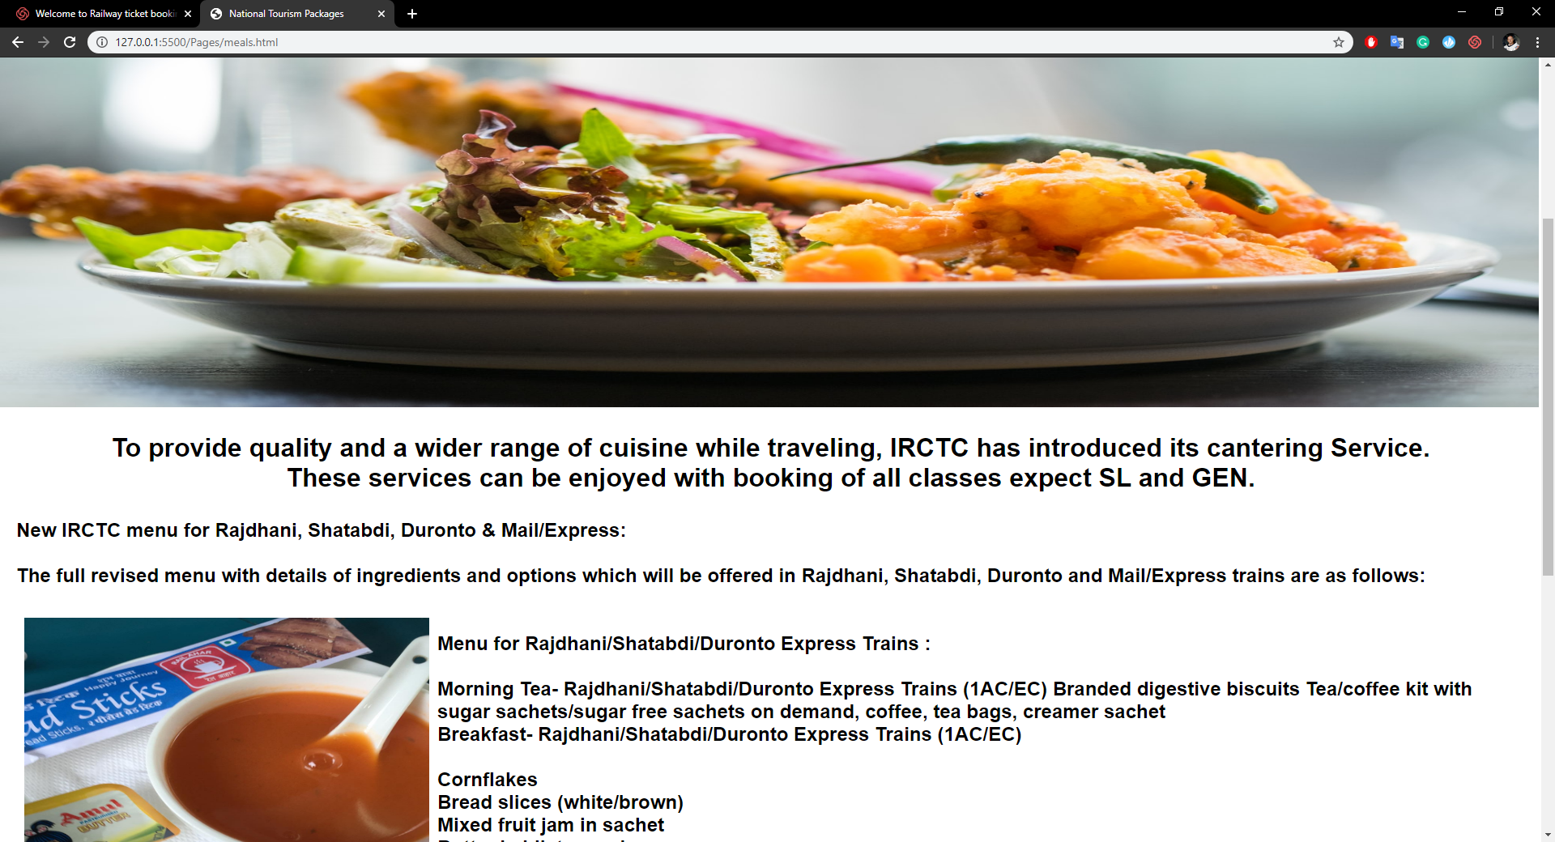

3.Holiday Packages: By clicking on it user can view all the national as well as international tour packages available.

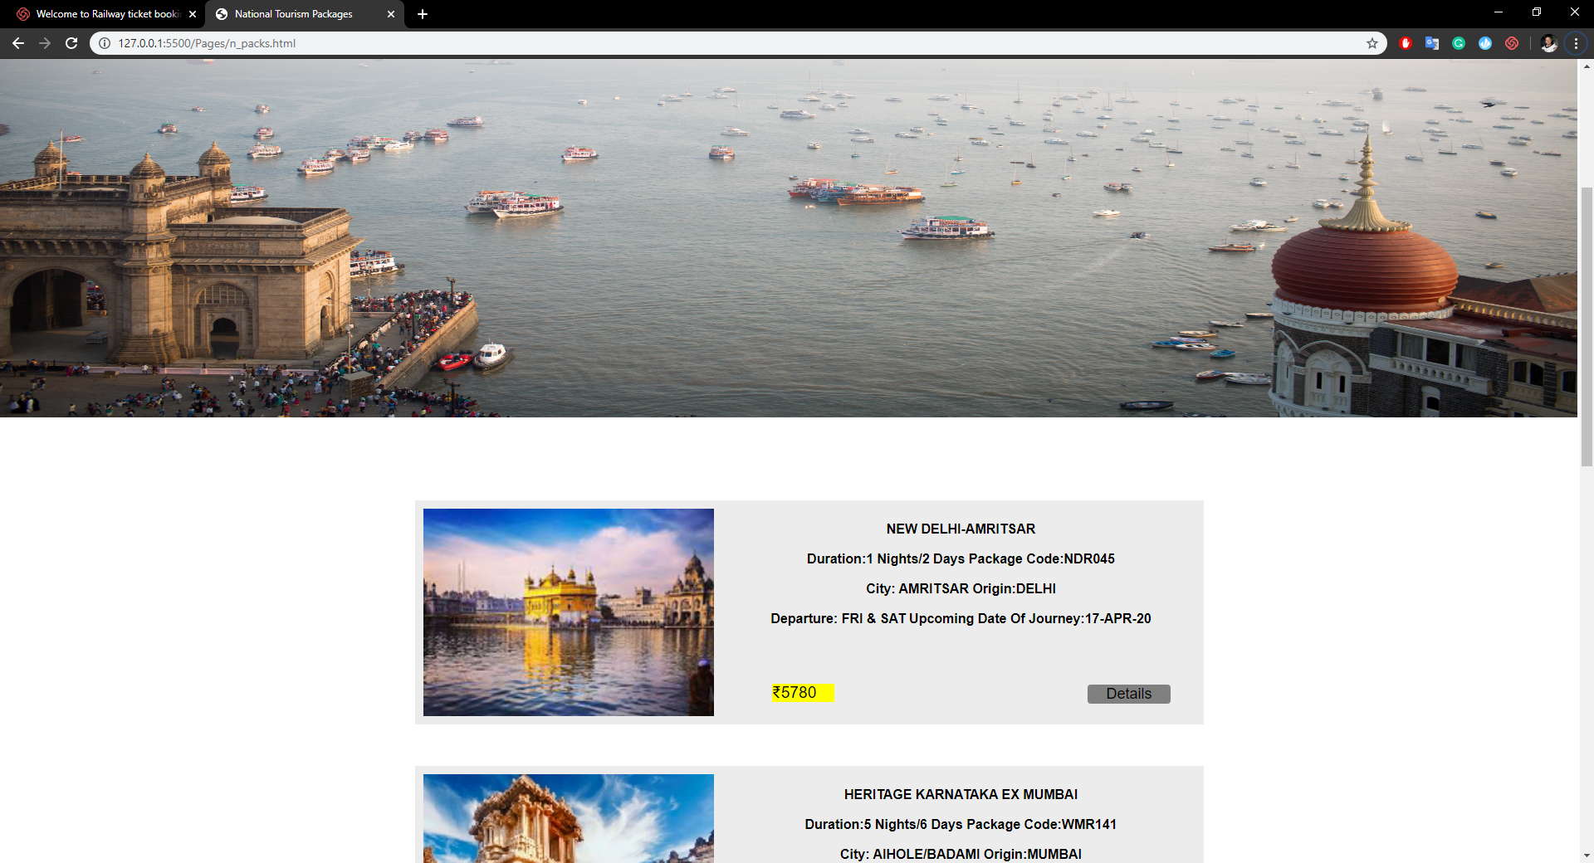

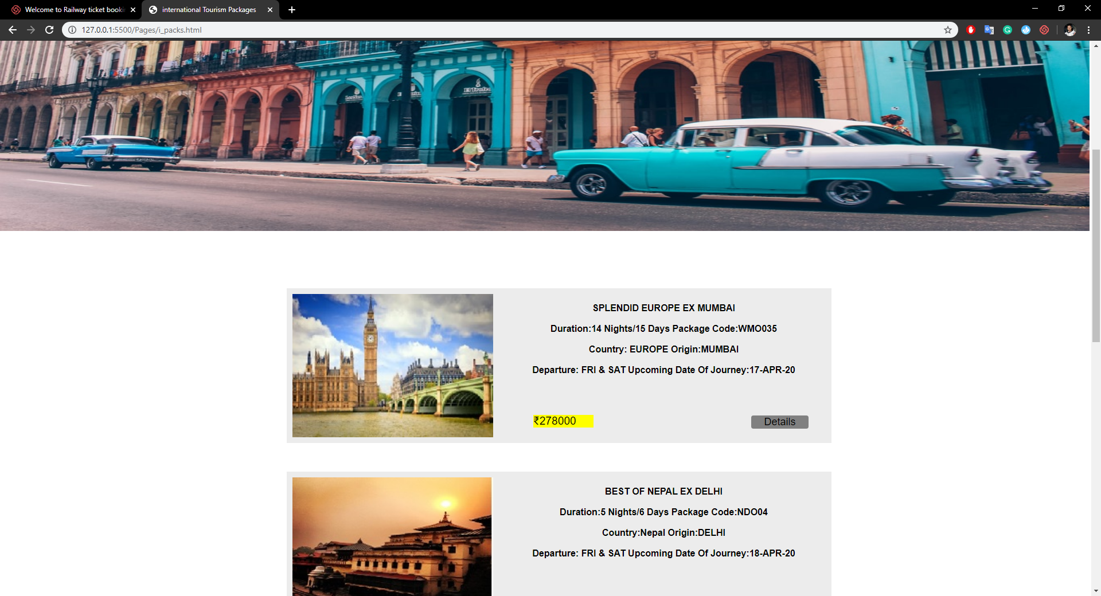

4.Services at station.: It contains the details of services which are available on stations. Like wifi-Railway Station, E wheelchairs, Battery operated cars.

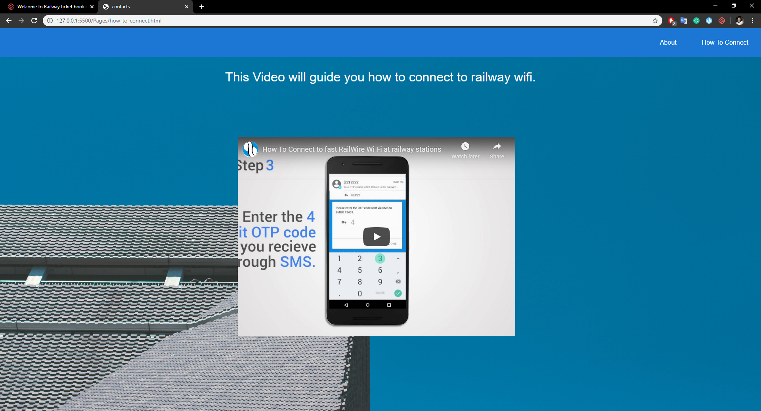

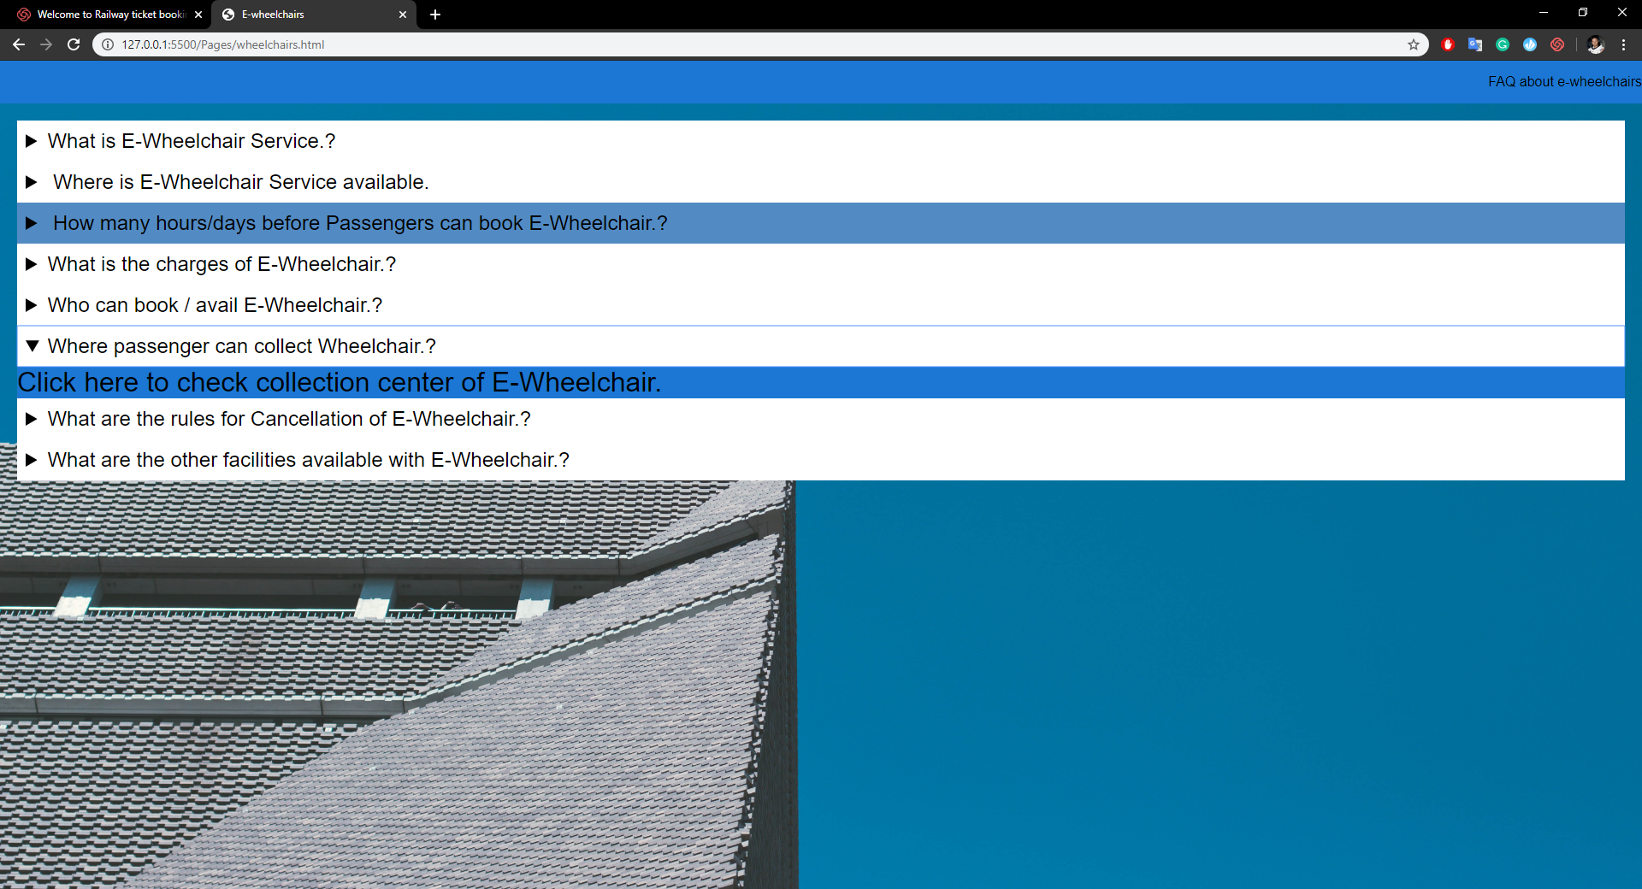

5.Contact Us. This Link contains the contact details of the website owner where the costumer can give feedback. e-mail or write to the owner.

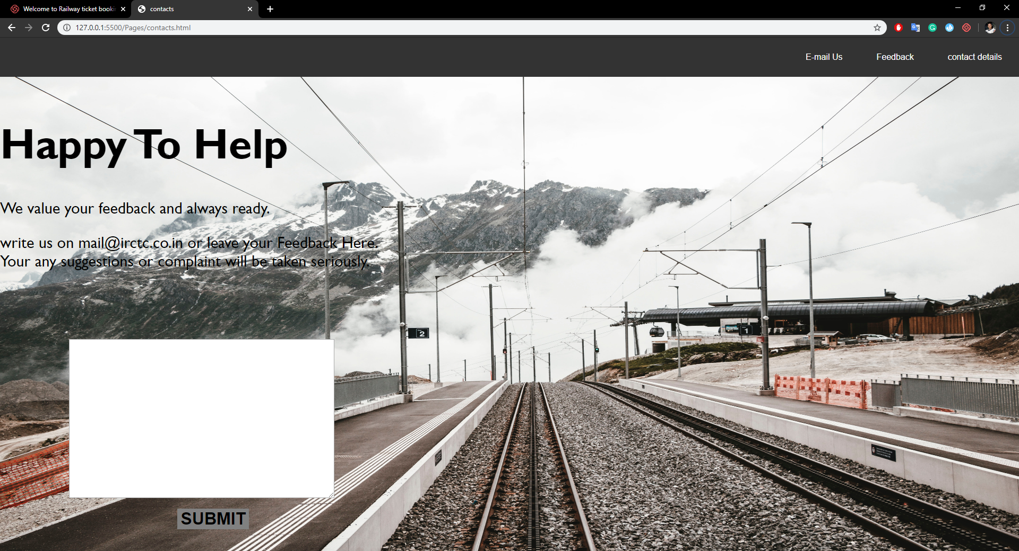

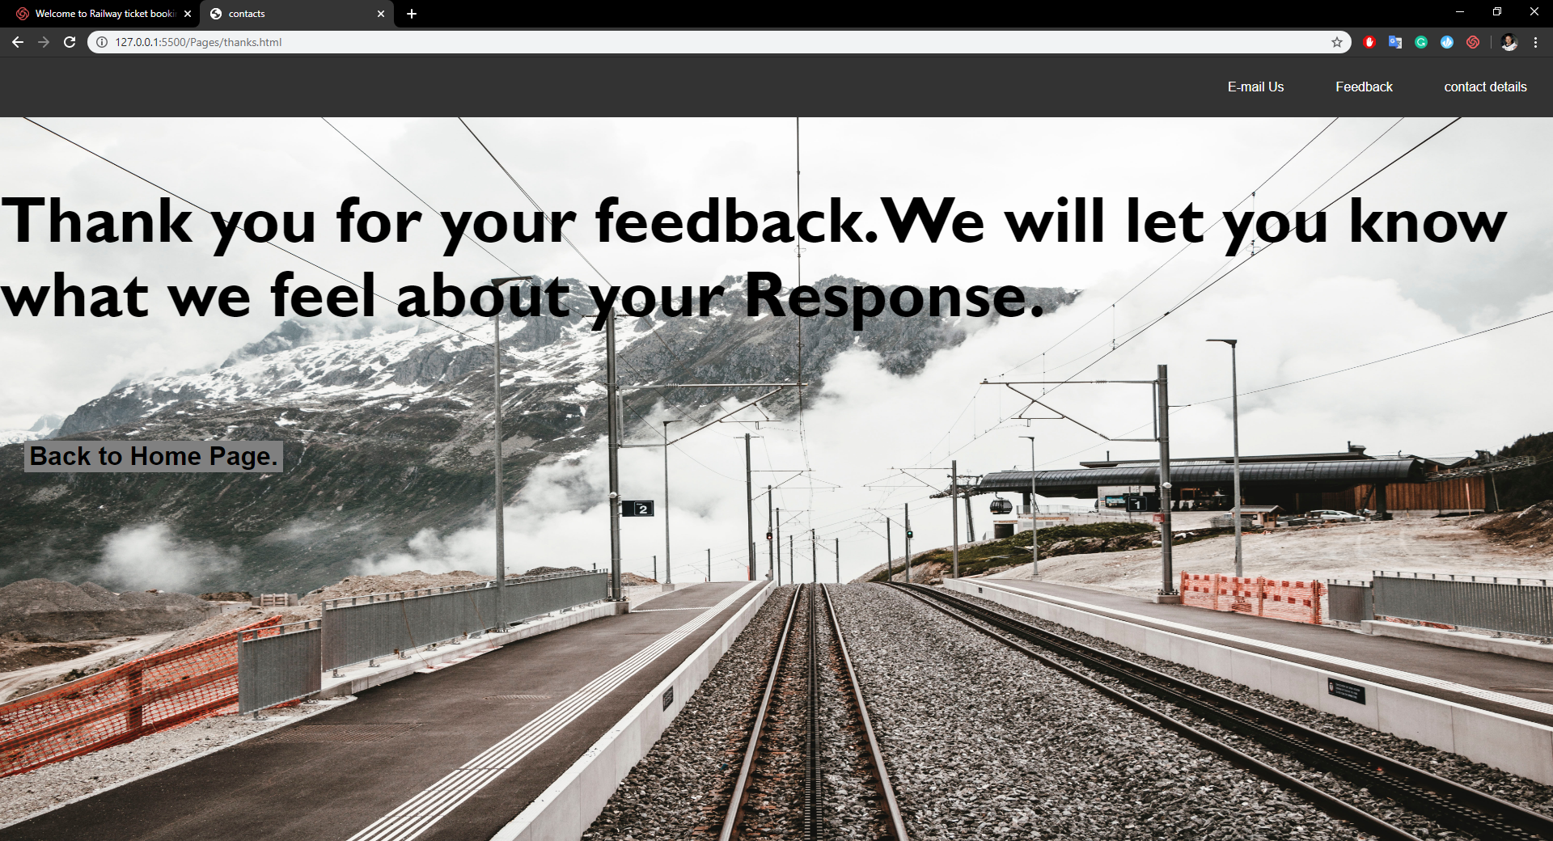

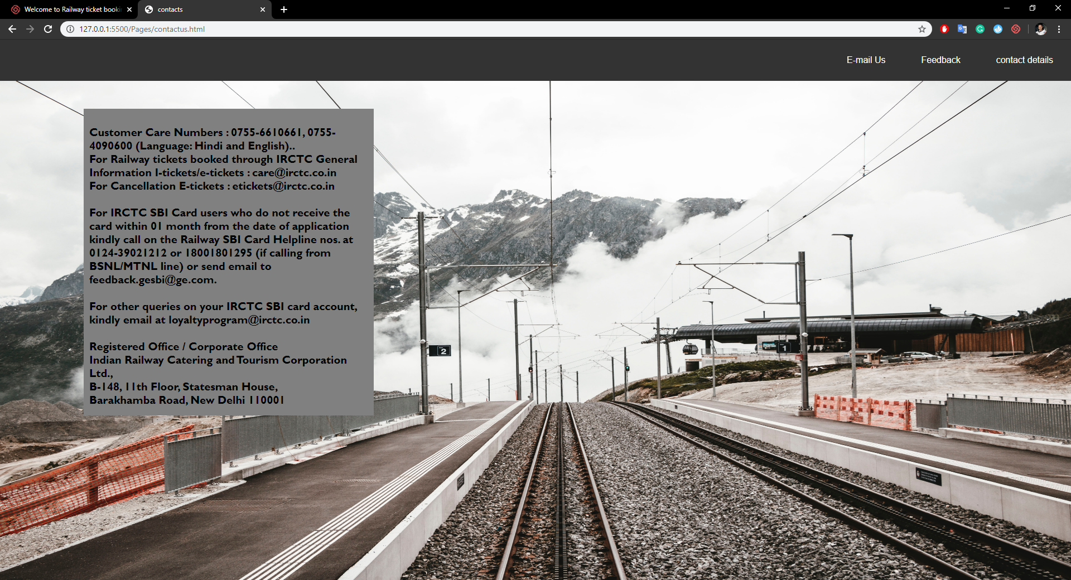

**TECHNOLOGIES AND FRAME WORKS USED: -**

We used notepad to write the program of website. We implemented HTML, CSS, JavaScript for development of program. we use chrome as a browser for the run of all the files.

**SWOT ANALYSIS**

1. **STRENGTH: -** The strength of this website ,passenger can book or cancel the tickets sitting in comfort of your home or office. Customer can save the time and efforts needed to travel to the railway reservation office and waiting in the queue for your turn .
2. **WEAKNESS: -**  The weakness of this website is most of the people are facing slow response from the website. It takes so much time to even Log In despite of fact that we use broadband internet. Sometimes after successful payments from net banking, redirecting requires more time .We don't know the exact reason for the same yet I think the server being used by the website might be the reason for this which might be having some or the other technical problem
3. **OPPORTUNITIES:** Their are ample of opportunities for web developer towards the online world .If you have a good skills in web designing will provide you huge opportunities .If you are in this field then you will get a chance to interact with good people . Also if we have the skills of making the website then we can have great salary packages in great companies. It also help the students as they can earn money as free lancers by creating websites.
4. **THREATS:-** Sometimes people are hesitate to give the personal information or online payment to website because sometimes the virus can crash the website and different types of malware functions can affect the website by blocking the website or by showing pop ups again and again.

EXPLANATION OF WORK DONE BY EACH STUDENT:

Sudharshan Reddy :-He collect the information regarding file and collect various images for website.

Sourabh Kumar :- Code and Design Rectification.

Khushboo Shakya :- Designing The layout of the page and flow of website and report work.